Michael Johnson

[Mdj0025@auburn.edu](mailto:Mdj0025@auburn.edu)

COMP 3710

Assignment 1

Use Case: As a user, I would like an Android application that converts from Fahrenheit to Celsius.

U.I. Sketch

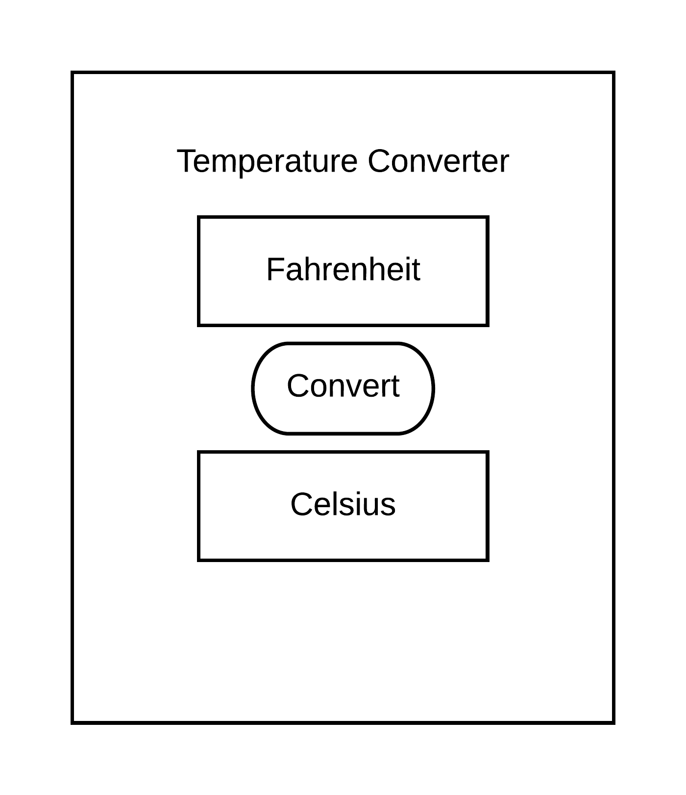

GitHub Link: <https://github.com/mdj0025/WirelessProject1>

Test Case

